**BLOCKCHAIN BASED CRIME EVIDENCE SYSTEM**

**Abstract**

In traditional crime evidence management systems, all data is stored on centralized servers that are vulnerable to tampering by administrators or malicious actors, compromising the integrity of criminal investigations. To address this critical issue, the proposed system employs blockchain technology to securely manage and store crime evidence details in a decentralized and tamper-proof manner. By leveraging Ethereum-based blockchain and smart contracts written in Solidity, the system ensures that every piece of evidence is stored as an immutable transaction linked by cryptographic hashes. Any attempt to alter data is immediately detected through hash mismatches, preserving the authenticity of records.The system features role-based access with separate modules for administrators and officers, enabling secure addition and retrieval of evidence data via a Django web interface. Admins can register officers and monitor all recorded cases, while officers can upload and access evidence directly into the blockchain. The use of smart contracts provides programmable control over data operations, and detailed logs such as transaction IDs and block numbers ensure transparency. This approach offers a robust, secure, and traceable platform for crime evidence handling, significantly enhancing the reliability and integrity of criminal justice procedures.

**Existing System:**  
In the existing crime evidence management systems, all crime and evidence records are stored in a centralized database maintained by the police department. This centralization poses a major risk, as the database can be tampered with by administrators or unauthorized users without detection. Since evidence is a crucial component in identifying and prosecuting the correct suspect, any alteration of these records can lead to false outcomes in legal proceedings. Furthermore, there is no dedicated mechanism or tool available in the current system to detect if data has been modified, which raises serious concerns about data integrity, transparency, and accountability.

**Proposed System:**  
The proposed system introduces a blockchain-based approach for managing crime evidence to overcome the limitations of the centralized model. Using Ethereum blockchain and smart contracts developed in Solidity, the system ensures that all evidence records are stored in a decentralized, tamper-proof ledger. Each transaction (evidence entry) is saved in blocks with unique hash values, making unauthorized changes easily detectable through hash mismatches. The system offers role-based access for administrators and officers via a Django web interface, enabling secure data operations like adding officers and uploading evidence. By providing immutable, verifiable records with full traceability, this blockchain-based system significantly enhances security, data integrity, and trust in criminal investigations.

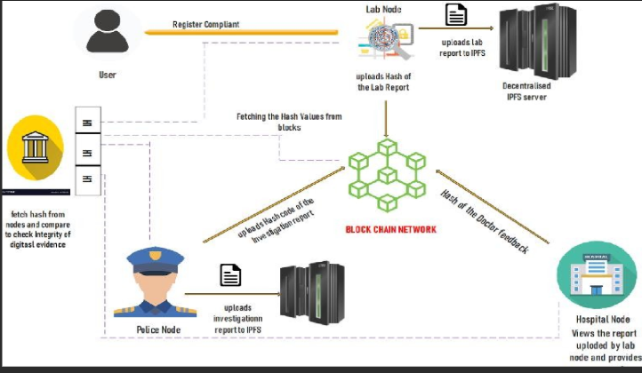

**SYSTEM REQUIREMENTS:**

**HARDWARE REQUIREMENTS:**

* Hard Disk  :   40 GB.
* Ram    :   512 MB.

**SOFTWARE REQUIREMENTS:**

* Operating system   : Windows 7
* Coding Language  : python